**Travel Information to New NSF Headquarters in Alexandria, Virginia**

Version of September 2017

NSF moves to Alexandria, Virginia in August and September 2017. The **new NSF address** is:

2415 Eisenhower Avenue, Alexandria, VA 22314

The building is one-minute-walk from the Eisenhower Ave Station on the Yellow Line of [Metro Rail](https://www.wmata.com/schedules/maps/) (Washington's subway system). It is also adjacent to I-495 (Washington's beltway).

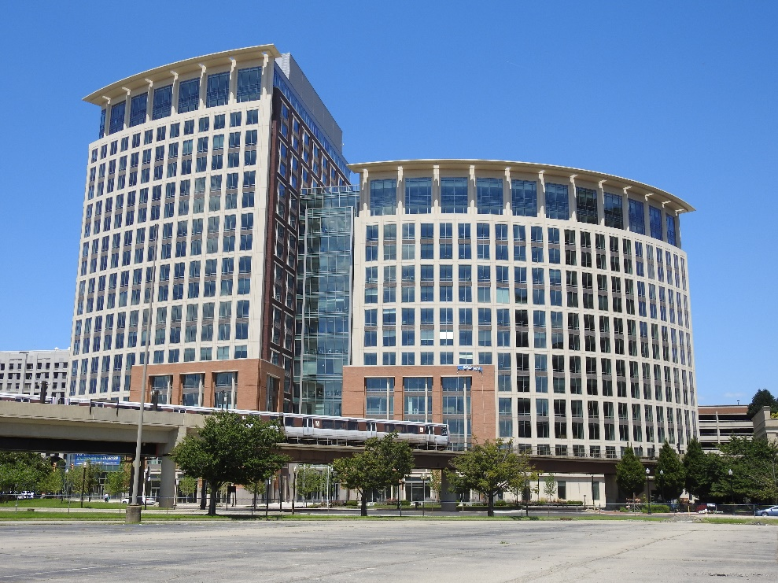

**Travel from Airports**

***DCA***: The [Ronald Reagan Washington National Airport](http://www.flyreagan.com/) is about 5 miles from the new NSF building. The fastest way to travel from the DCA Airport to NSF (about 10 minutes) is to use [Metro Rail](https://www.wmata.com/schedules/maps/) Yellow Line towards *Huntington*. The new NSF Building is next to the *Eisenhower Ave Station*, which is the third stop from the DCA Airport.

***IAD***: The [Dulles Washington International Airport](http://www.flydulles.com/) is about 30 miles from the new NSF building. Public transportation options, using either [Silver Line Express Bus](http://www.flydulles.com/iad/silver-line-express-bus-metrorail-station) (every 15-20 minutes) or [Metrobus 5A](https://www.wmata.com/schedules/timetables/upload/05a.pdf) (every 30-60 minutes) ***and*** then connecting to [Metro Rail](https://www.wmata.com/schedules/maps/), will take about 90 minutes. If driving from the IAD Airport, use the Dulles Access Road towards Washington DC for about 13 miles, take exit 18A for *I-495* South, drive along I-495 for about 16 miles, take exit 176B for *VA-241 N/Telegraph Rd/Eisenhower Ave* towards Alexandria, keep right and follow signs for *Eisenhower Avenue*, and turn right to Eisenhower Avenue.

***BWI***: The [Baltimore/Washington International Thurgood Marshall Airport](http://www.bwiairport.com/) is about 45 miles from the new NSF building.

**Travel from Amtrak's Union Station**

Get off [Amtrak](https://www.amtrak.com/) train at the Union Station of Washington DC. Take [Metro Rail](https://www.wmata.com/schedules/maps/) Red Line at the Union Station towards *Shady Grove* or *Grosvenor*. At *Gallery Place* (2 stops from the Union Station), change to [Metro Rail](https://www.wmata.com/schedules/maps/) Yellow Line towards *Huntington*. The new NSF Building is next to the *Eisenhower Ave Station* (9 stops from Gallery Place). The trip takes about 30 minutes.

**NSF Building Entrance**

Panelists/visitors need to use the south entrance of the new NSF building, at the Eisenhower Avenue. The north entrance at the Frist Mill Place is for NSF employees only.

***The south entrance of the NSF building***

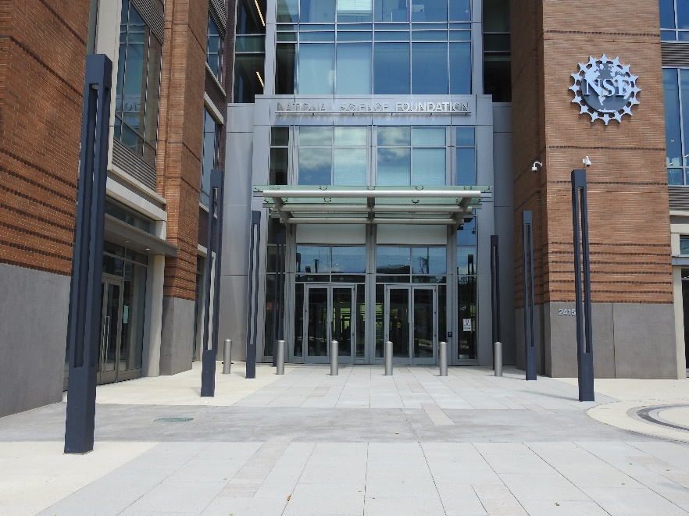

***NSF Visitor Center, when visitors/panelist get their visitor passes***

[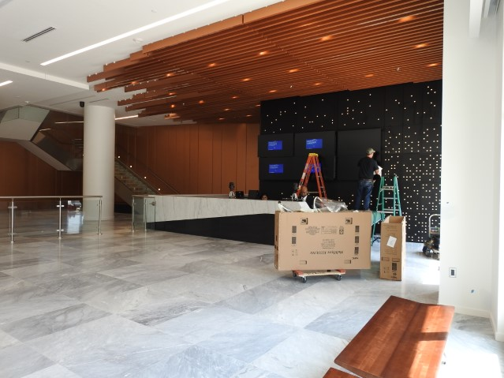](https://collaboration.inside.nsf.gov/sites/futurensf/Pictures/DSCN1720.JPG)

***X-ray machine and metal detector for visitor/panelist screening***

[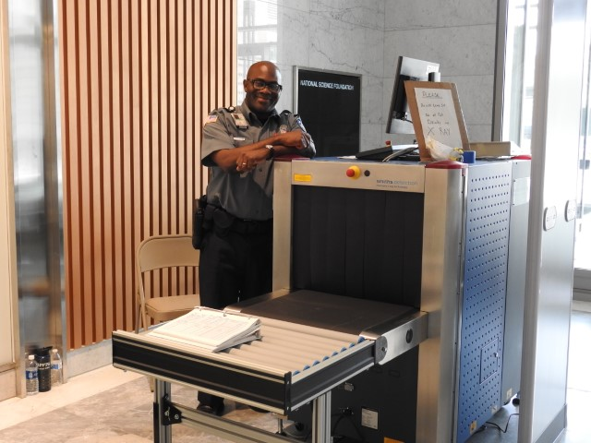](https://collaboration.inside.nsf.gov/sites/futurensf/Pictures/DSCN1721.JPG)

***A large staircase connecting the first, second, and third floors (elevators available too)***

[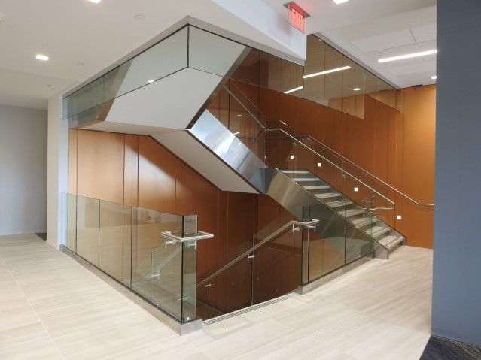](https://collaboration.inside.nsf.gov/sites/futurensf/Pictures/DSCN1713.JPG)

**Multi-purpose room**

The multiple-purpose room (Room E2030/E2030) on the second floor is where the workshop will be held.

[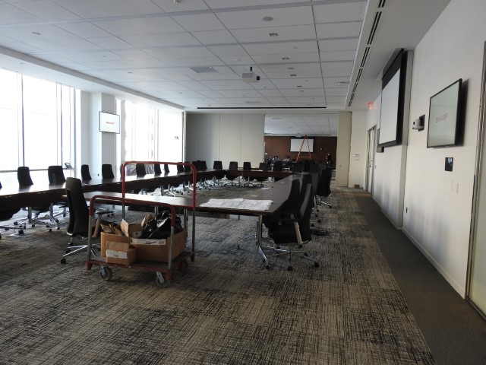](https://collaboration.inside.nsf.gov/sites/futurensf/Pictures/DSCN1659.JPG)

**Parking**

PMI operates a large parking garage at the [AMC Hoffman Center](https://www.amctheatres.com/movie-theatres/washington-d-c/amc-hoffman-center-22), at the north side of the new NSF building, and a surface parking lot at the south side of the NSF building. Parking costs about $7 per day at either place, and the parking garage at the AMC Hoffman Center has more spaces.

The parking garage in the basement of the new NSF building is for NSF employees only.

**Hotels** (ordered by distance)

[Holiday Inn Alexandria - Carlyle](https://www.ihg.com/holidayinn/hotels/us/en/alexandria/axetd/hoteldetail)

2460 Eisenhower Ave, Alexandria, VA 22314

703-960-2000

0.2 mile from the new NSF building

[Residence Inn Alexandria Old Town South at Carlyle](http://www.marriott.com/hotels/travel/wasra-residence-inn-alexandria-old-town-south-at-carlyle/)

2345 Mill Road, Alexandria, VA 22314

703-549-1155

0.3 mile from the new NSF building

[Westin Alexandria](http://www.westinalexandria.com/)

400 Courthouse Square, Alexandria, VA 22314

703-253-8600

0.4 mile from the new NSF building

[Courtyard by Marriott Alexandria Old Town/Southwest](http://www.marriott.com/hotels/travel/wasal-courtyard-alexandria-old-town-southwest/)

2700 Eisenhower Ave, Alexandria, VA 22314

703-329-2323

0.5 mile from the new NSF building

There are additional hotels ([Embassy Suites by Hilton Alexandria Old Town](http://embassysuites3.hilton.com/en/hotels/virginia/embassy-suites-by-hilton-alexandria-old-town-WASOTES/index.html), [Hilton Alexandria Old Town](http://www3.hilton.com/en/hotels/virginia/hilton-alexandria-old-town-DCAOTHF/index.html), [Hilton Garden Inn Alexandria Old Town](http://hiltongardeninn3.hilton.com/en/hotels/virginia/hilton-garden-inn-alexandria-old-town-king-st-metro-DCAOLGI/index.html), [Wyndham Old Town Alexandria](https://www.clubwyndham.com/cw/resorts/wyndham-old-town-alexandria.page), ...) at about 1 mile from the new NSF building. These hotels are also near the King Street Station of [Metro Rail](https://www.wmata.com/schedules/maps/) Yellow Line.

**Restaurants**

For information about restaurants near the NSF Building, you may use this [link](https://www.tripadvisor.com/RestaurantsNear-g30226-d9574943-Eisenhower_Ave-Alexandria_Virginia.html).

A cafeteria, Whaler's Café, on the second floor of the NSF building is open to NSF employees and panelists/visitors from 7 AM to 3 PM.

***Whalers Café on the second floor has 5 stations. 2 stations are shown:***

[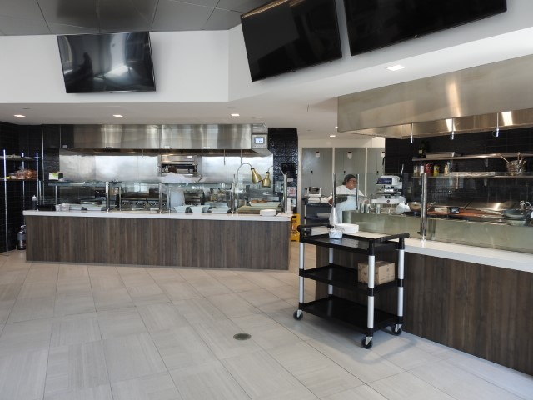](https://collaboration.inside.nsf.gov/sites/futurensf/Pictures/DSCN1710.JPG)

Whalers Café has 5 stations:

* Station #1: Soups and Salads – Premium, custom-made salads and daily soups.
* Station #2: Sandwiches – Breakfast and lunch sandwiches, with a selection of meats, proteins, cheeses, and vegetarian/vegan options.
* Station #3: Pizza/Flatbread/Quesadillas/Tacos – Customizable flatbreads and pizza offered with choice of proteins, cheeses, and vegetables. Multiple types of tacos and quesadillas with homemade salsa. Pizza and flatbreads feature fresh dough.
* Station #4: Pastries – Pastries baked fresh daily.
* Station #5: Grill – Made to order omelets, gourmet burgers, and hot plates such as grilled salmon, halibut, vegetarian lasagna, and more.

***Drink at the Whalers Café***

[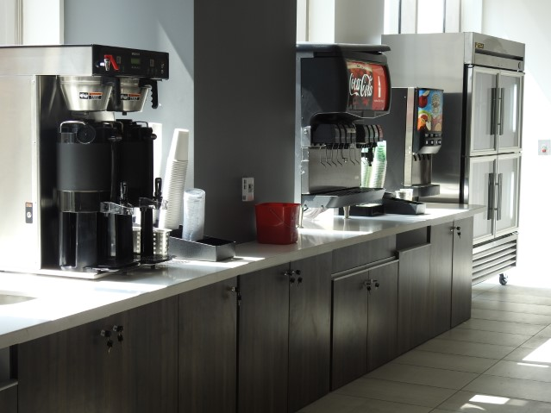](https://collaboration.inside.nsf.gov/sites/futurensf/Pictures/DSCN1708.JPG)

***Seating area of the cafeteria on the second floor***

[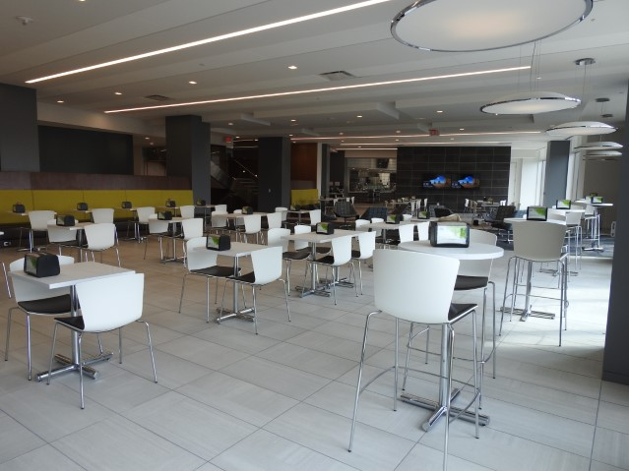](https://collaboration.inside.nsf.gov/sites/futurensf/Pictures/DSCN1702.JPG)